QS8: STAR LAWS (Shedding Light on Astronomy)
Episode VIII: Why does the Sun get Higher in the Sky in Summer than it does in Winter?
Name: _________________________________________________
- The Sun rises in the general direction of ______________, gets to its highest angle above the horizon in the middle of the day and then sets in the general direction of _____________.
- Why are shadows (of trees, for example) longer in the morning and in the evening than they are in the middle of the day? _______________________________________________________________________________
____________________________________________________________________________________________________________________________________________________________________________________________________________________________________________________________________________________
- What is solar noon? ________________________________________________________________________
________________________________________________________________________________________________________________________________________________________________________________________

- Mark in (below) a path representing the Sun’s movement from sunrise, to solar noon, to sunset.
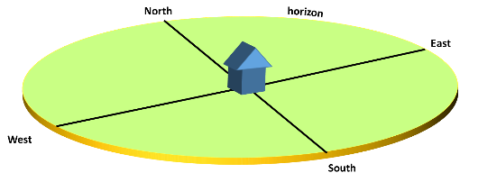
- “am” (eg. 7 am) stands for _______________________________ which means _________________________________________.
- “pm” (eg 5 pm) stands for _______________________________ which means _________________________________________.
- The Sun always gets to its highest elevation (aka altitude) at solar noon. What is meant by the word elevation? ________________
__________________________________________________________________________________________
__________________________________________________________________________________________

 | Elevation of Sun at Solar Noon Throughout the Year
Date | ____________,  ____________  Latitude:  ____________ | ____________,  ____________  Latitude:  ____________
Jan 1
Feb 1
Mar 1
March 21 (Equinox)
April 1
May 1
Jun 1
June 21 (Solstice)
Jul 1
Aug 1
Sep 1
September 23 (Equinox)
Oct 1
Nov 1
Dec 1
December 21
(Solstice)
Note: the dates on which the solstices and the equinoxes occur vary slightly year to year.
- Go to the Time and Date website (www.timeanddate.com), hover over the Sun, Moon & Space drop-down menu item, and then click Sun Calculator. Search for your city (or town) and/or any other location that you may have a connection with. Scroll down and find the Solar Noon column in the table. Use the information to complete the table on the left and to then draw up a line graph for the Sun’s elevation (aka altitude) in your two locations for solar noon throughout the year. (The timeanddate.com website uses the word altitude, not elevation, but they mean the same thing.)
Each solid vertical line represents the start of the month.
Jan Feb Mar Apr May Jun Jul Aug Sep Oct Nov Dec
Elevation (altitude) of the Sun at solar noon in
____________________ and in ______________________
Equinox Solstice Equinox Solstice

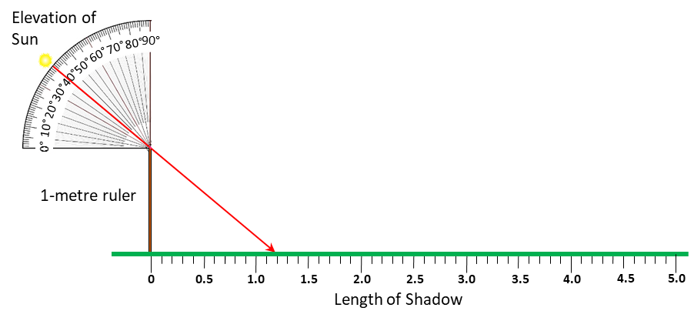
- Use the diagram below to work out the approximate shadow height of a one-metre ruler at solar noon on the days of the two solstices and on one of the equinoxes. Complete the table. Use the data that you collected on Page 1. (An example is shown where the Sun is at an elevation of 40°. The beam of sunlight that just passes the top of the ruler hits the ground at 1.19 metres. The shadow of a 1-metre ruler is therefore 1.19 metres long when the Sun is at the elevation shown.)
Location: ________________________
Latitude: ___________
Event | Date | Elevation of Sun at Solar Noon (degrees) | Length of Shadow of 1-m ruler (metres)
December Solstice
March Equinox
June Solstice
- Comment on how the elevation of the Sun at solar noon changes throughout the year (for your location).
________________________________________________________________________________________________________________________________________________________________________________________________________________________________________________________________________
EXTENSION:
- What is the difference in degrees in the elevation of the Sun at solar noon between the two solstices?
_________________.
- Compare this figure with the figures attained by your classmates for the cities that they collected data for. What do you notice? _______________________________________________________________________
- If you halve the figure you calculated in Q11, you get __________, which is more or less equal to the ___________ of the Earth with respect to the orbital plane. So, can you explain your answer to Q12?










